

QR-BASED CATTLE MANAGEMENT SYSTEM :
A PLATFORM FOR PERSONALIZED
HEALTHMONITORING USING COMPOSITE
HEALTH DEVIATION INDEX (CHDI)

A Project Report

U23ADS705 – MINI PROJECT
Submitted by
SABARI KARTHICK A | (61782323110093)
SIVANARASIMMAN S | (61782323110103)
SUJEETH Y R | (61782323110107)
in partial fulfillment for the award of the degree
of
BACHELOR OF TECHNOLOGY
in
ARTIFICIAL INTELLIGENCE AND DATA SCIENCE
SONA COLLEGE OF TECHNOLOGY (AUTONOMOUS), SALEM – 636005
ANNA UNIVERSITY: CHENNAI 600 025
OCTOBER 2026
SONA COLLEGE OF TECHNOLOGY (AUTONOMOUS)
ANNA UNIVERSITY: CHENNAI – 600 025
BONAFIDE CERTIFICATE
Certified that this project titled “QR-BASED CATTLE MANAGEMENT SYSTEM: A PLATFORM FOR PERSONALIZED HEALTH MONITORING USING COMPOSITE HEALTH DEVIATION INDEX (CHDI)” is the bonafide work of “SABARI KARTHICK A (61782323110093), SIVANARASIMMAN S (61782323110103), SUJEETH Y R (617823231100107)” who carried out the project work U23ADS705 – MINI PROJECT under my supervision.

Signature of the Supervisor | Signature of the Head of the Department
Ms. J. Deepika | Dr. J. Akilandeswari
Assistant Professor | Professor & Head
Department of Information Technology | Department of Information  Technology
Sona College of Technology  Salem – 636005 | Sona College of Technology  Salem – 636005
Submitted for the Project Viva-Voce Examination held on ______________

INTERNAL EXAMINER | EXTERNAL EXAMINER
Sona College of Technology
Department of Information Technology
U23ADS705 – MINI PROJECT - DECLARATION FORM
Declaration by the Student(s)
We hereby declare that the project titled “QR-BASED CATTLE MANAGEMENT SYSTEM: A PLATFORM FOR PERSONALIZED HEALTH MONITORING USING COMPOSITE HEALTH DEVIATION INDEX (CHDI)” is an original work carried out by me/us under the guidance of MS. J. DEEPIKA. This project has not been submitted elsewhere for the award of any degree.
We also affirm that all the data and information used in this project are genuine and properly acknowledged. This project work is carried out with reference to the United Nations Sustainable Development Goals: 2 – ZERO HUNGER, 9 – INDUSTRY, INNOVATION AND INFRASTRUCTURE, 3 – GOOD HEALTH AND WELL-BEING, 12 – RESPONSIBLE CONSUMPTION AND PRODUCTION.
S.No | Register Number | Name | Signature
1. | 61782323110093 | SABARI KARTHICK A
2. | 61782323110103 | SIVANARASIMMAN S
3. | 61782323110107 | SUJEETH Y R

Date: ___________________
Place: Sona College of Technology
ACKNOWLEDGMENT
First and foremost, we thank the Almighty for His blessings, guidance, and the inner peace that gave us the strength and determination to complete this project. We also express our heartfelt gratitude to our parents for their unconditional love, constant support, and encouragement throughout our journey.
We express our sincere gratitude to our beloved Chairman, Sri. C. Valliappa, and our dynamic Vice-Chairmen, Sri. Chocko Valliappa and Sri. Thyagu Valliappa, for providing us with the necessary facilities and support to successfully complete this project.
We are immensely grateful to our Principal, Dr. S. R. R. Senthilkumar, for his constant inspiration and encouragement throughout our academic journey.
We extend our sincere thanks to Dr. J. Akilandeswari, Professor and Head of the Department of Information Technology, for providing the necessary laboratory facilities and academic support to carry out this project successfully.
We express our heartfelt gratitude to our Project Coordinator, Dr. J. Jeba Emilyn, Associate Professor, Department of Information Technology, for her continuous guidance, valuable suggestions, and constant encouragement throughout the project.
We are also deeply grateful to Ms. J. Deepika, Assistant Professor, Department of Information Technology, for her invaluable mentorship, insightful guidance, and unwavering support throughout the project. Her expertise and constructive suggestions have played a significant role in shaping our work and helping us achieve our objectives.
Finally, we take this opportunity to express our sincere appreciation to all the faculty members, non-teaching staff, and friends who supported us, either directly or indirectly, in completing this project successfully. Their cooperation and encouragement have contributed greatly to the successful completion of our work.
ABSTRACT
The use of precision livestock health monitoring in smallholder dairy farms is often limited by the cost of RFID readers, proprietary wearable sensors, and conventional monitoring methods that rely on fixed thresholds across a herd. These approaches may generate false alarms because they do not adequately account for individual cattle variations and limited historical health data.
To address these challenges, the QR Based Cattle Management System is proposed as an infrastructure-light, cloud-based platform for cattle health monitoring using the Composite Health Deviation Index (CHDI). The system uses weather-resistant QR codes linked to digital cattle profiles, which can be accessed using standard smart devices. Role-Based Access Control (RBAC) helps manage access to cattle records and health information. At its core, the system uses a personalized 14-day health baseline and multivariate Mahalanobis distance to evaluate deviations across four health parameters: body weight, feed intake, milk production, and body temperature. It also supports health trend analysis, feature attribution, and data-sufficiency checks to reduce unreliable assessments when historical observations are limited.
The application is developed using Next.js for the web interface and application logic, PostgreSQL with Prisma ORM for data storage, and a dedicated Python FastAPI microservice for analytical processing. The responsive web application supports QR-based cattle identification, health record management, CHDI assessment, and veterinary case management. The proposed system aims to provide an accessible and practical approach to personalized cattle health monitoring, helping farmers identify unusual health patterns and supporting timely veterinary review.
TABLE OF CONTENTS
Title | Page No.
1. 1. INTRODUCTION | 1
1.1 Background of the Project | 1
1.2 Problem Statement | 1
1.3 Motivation | 2
1.4 Objectives | 2
1.5 Scope of the Project | 3
2. LITERATURE REVIEW | 4
2.1 Introduction | 4
2.2 Review of Related Studies | 4
2.3 Techniques and Technologies Used in Existing Systems | 7
2.4 Research Gap | 7
2.5 Summary | 8
3. CHAPTER 1 – NEED FOR PROPOSED TECHNIQUE | 9
3.1 Existing Techniques | 9
3.2 Limitations of Existing Techniques | 9
3.3 Proposed Technique | 9
3.4 Objectives of the Proposed Technique | 10
3.5 Advantages of the Proposed Technique | 10
4. CHAPTER 2 – DESIGN OF PROPOSED SYSTEM AND ITS IMPLEMENTATION | 11
4.1 Introduction | 11
4.2 System Requirements | 11
4.2.1 Hardware Requirements | 11
4.2.2 Software Requirements | 12
4.3 System Architecture | 12
4.4 System Modules | 13
4.4.1 Module 1: User Authentication and Access Control Module | 13
4.4.2 Module 2: Cattle Identification and Management Module | 14
4.4.3 Module 3: Cattle Health Data Logging Module | 14
4.4.4 Module 4: Medical and Vaccination Management Module | 14
4.4.5 Module 5: Health Baseline and CHDI Calculation Module | 14
4.4.6 Module 6: Health Trends and Weekly Analytics Module | 15
4.4.7 Module 7: Health Analysis and Explainability Module | 15
4.4.8 Module 8: Veterinary Alerts & Feedback Learning Module | 15
4.5 Proposed Methodology | 15
4.6 System Workflow | 16
4.7 Techniques Used | 17
4.8 Data Collection | 23
4.9 Data Preprocessing | 24
4.10 Model Development | 25
4.11 System Design Diagrams | 26
4.12 Implementation | 28
4.13 Coding Implementation | 28
4.14 User Interface Screens | 33
4.15 Chapter Summary | 36
5. CHAPTER 3 – RESULTS AND DISCUSSION | 37
5.1 Introduction | 37
5.2 Experimental Setup | 37
5.3 Evaluation Metrics | 37
5.4 Experimental Results | 38
5.5 Comparison with Existing Techniques | 41
5.6 Discussion of Results | 42
5.7 Chapter Summary | 42
6. CHAPTER 4 – CONCLUSION AND FUTURE SCOPE | 43
6.1 Summary of the Project | 43
6.2 Conclusion | 43
6.3 Future Scope | 43
SDG GOALS | 44
REFERENCES | 46

LIST OF FIGURES
Figure No. | Title | Page No.
4.1 | Overall System Architecture | 13
4.2 | System Workflow and Health Analysis | 16
4.3 | CHDI Baseline and Anomaly Detection | 23
4.4 | CHDI System Design | 26
4.5 | Regional Heatmap and Outbreak Detection | 27
4.6 | Farmer Dashboard | 33
4.7 | Cattle QR Scanner and Digital Identity | 33
4.8 | Cattle Health Records and CHDI History | 34
4.9 | Veterinary Health Assessment Interface | 35
4.10 | Cattle List and Health Status | 35
5.1 | CHDI Health Status Distribution | 38
5.2 | CHDI Trend Showing Early Health Alerts | 40
5.3 | Feature Importance for Health Anomaly Detection | 40
LIST OF TABLES
Table No. | Title | Page No.
4.1 | Hardware Requirements | 11
4.2 | Software Tools and Technologies | 12
4.3 | CHDI Levels and Clinical Actions | 17
4.4 | Health Indicators and Normal Values | 24
4.5 | GitHub Repository Structure | 29
5.1 | Anomaly Detection Performance Metrics | 39
5.2 | Comparison with Existing Health Monitoring Methods | 41
5.3 | CHDI Component Ablation Study | 41
LIST OF ABBREVIATIONS
Abbreviation | Full Expansion
API | Application Programming Interface
BRD | Bovine Respiratory Disease
CHDI | Composite Health Deviation Index
F1 | Harmonic Mean of Precision and Recall
IoT | Internet of Things
LF | Low Frequency
ML  CMT | Machine Learning  California Mastitis Test
OLS | Ordinary Least Squares
ORM | Object-Relational Mapping
PLF | Precision Livestock Farming
QR | Quick Response Code
RBAC | Role-Based Access Control
RFID  WSN | Radio-Frequency Identification  Wireless Sensor Network
UHF | Ultra-High Frequency
UI  LOCO | User Interface  Leave-One-Covariate-Out

1. INTRODUCTION
1.1 Background of the Project
Smallholder dairy farming plays an important role in India's agricultural economy by providing nutritional security, employment and regular income to farmers. However, cattle health management faces challenges such as delayed disease detection, manual record maintenance and the high cost of commercial Precision Livestock Farming (PLF) technologies. Diseases such as subclinical bovine mastitis, bovine respiratory disease (BRD) and metabolic disorders can reduce milk production and increase veterinary expenses. Aquilani et al. [2] reviewed Precision Livestock Farming technologies, while Curti et al. [5] and Garg et al. [8] explored machine learning approaches for cattle health assessment and disease prediction. These studies highlight the potential of data-driven techniques for identifying unusual health patterns.
Traditional cattle management often relies on physical observation and manually maintained records, making it difficult to track changes in individual animals over time. Bumbálek et al. [4] examined non-invasive cattle identification methods, including QR code collars, while Kumar and Sharma [14] discussed the accessibility of precision livestock technologies for smallholder farmers. To address these challenges, the proposed project introduces a QR-based cattle management platform that provides digital animal profiles, centralized health records and a personalized Composite Health Deviation Index (CHDI). The system uses recorded health parameters to identify deviations from individual historical patterns, aiming to support early recognition of potential health concerns without requiring specialized monitoring hardware.

1.2 Problem Statement
Smallholder dairy farmers and rural veterinary personnel often lack access to affordable, accessible and reliable digital tools for livestock monitoring. The major problems that need to be addressed are explained below.
1. Expensive RFID Systems: Passive Low-Frequency (LF) and Ultra-High-Frequency (UHF) RFID ear tags and reader antennas may involve additional equipment and maintenance costs. Pereira et al. [16] reviewed passive UHF RFID applications in animal tracking, while Bumbálek et al. [4] examined cattle identification methods, including QR code collars. For small farms, smartphone-based QR identification can provide an alternative that reduces dependence on dedicated readers.
2. Fixed Thresholds and False Alarms: Standard monitoring systems may use fixed thresholds to identify health problems. However, body weight, milk yield, feed intake and temperature naturally vary between individual cows, breeds and lactation stages. Fan et al. [7] discussed personalized anomaly detection in physiological telemetry, highlighting the relevance of individual patterns when evaluating deviations. Therefore, a monitoring system should consider each animal's historical data instead of depending entirely on uniform thresholds.
3. Limited Farm Data: Rural farm data collection is often limited or irregular. Newly registered cattle may not have sufficient historical observations to establish a reliable baseline. Mehta et al. [15] discussed selective classification and abstention mechanisms for clinical machine learning, which are relevant to withholding an assessment when available evidence is insufficient. The proposed system therefore incorporates a data-sufficiency mechanism to reduce unreliable health alerts.
4. Difficulties in Record Management: Maintaining cattle identification, vaccination details, health observations and veterinary records separately can make information retrieval difficult. Subach and Shmeleva [18] discussed digital innovations in livestock farming. A centralized digital platform can organize these records and make them accessible to authorized users.
These problems highlight the need for a cost-effective system that combines digital identification, personalized health analysis and veterinary case management in a single platform.
1.3 Motivation
The main objective of the project is to make precision livestock health monitoring accessible to smallholder dairy farmers through an infrastructure-light, cloud-native software platform. The proposed system uses QR digital passports instead of expensive proprietary identification hardware, allowing cattle records to be accessed through a smartphone camera.
Bumbálek et al. [4] examined non-invasive cattle identification methods, including QR code collars. Aquilani et al. [2] reviewed Precision Livestock Farming technologies, while Kumar and Sharma [14] discussed the accessibility of these technologies for smallholder farmers. Curti et al. [5] investigated machine learning algorithms applied to individual cow health records, and Garg et al. [8] explored multiparametric machine learning models for early bovine disease prognosis. These studies provide relevant context for developing an affordable, data-driven cattle management solution.
Building on these approaches, the proposed system uses a personalized Three-Stage Composite Health Deviation Index (CHDI) engine to identify deviations from an individual animal's historical baseline. The system also incorporates seven-day health trend analysis and data-sufficiency checks to improve the interpretation of observations. Veterinary case management functions help organize potential health concerns and record clinical feedback. The overall motivation is to provide an accessible digital solution that supports cattle health management without requiring specialized monitoring hardware.
1.4 Objectives
The following are the key objectives of the proposed system:
1. Infrastructure-Independent Livestock Identification: To create a secure QR animal passport linked to cloud-based health records and accessible through a smartphone camera instead of expensive RFID readers.
2. Personalized Longitudinal Baseline Modeling: To design and implement a multivariate Mahalanobis distance-based Three-Stage Composite Health Deviation Index (CHDI) engine that creates a personalized 14-day rolling physiological baseline and identifies deviations in the recorded health signals.
3. Explainability and Uncertainty Estimation: To apply ordinary least-squares regression for analyzing seven-day health trends, implement a data-sufficiency gate to reduce unreliable alerts during early enrollment, and use leave-one-covariate-out (LOCO) feature attribution to explain the factors contributing to detected health deviations.
4. Automated Clinical Triage Pipeline: To develop a veterinary case management workflow that prioritizes critical cases, routes urgent cases to attending veterinarians, records veterinary feedback for continuous improvement and tracks clinical diagnoses.
5. Full-Stack Web Application Prototype: To design and develop a web application using Next.js App Router and API Route Handlers, Prisma ORM, PostgreSQL and a dedicated FastAPI Python microservice, with mobile-friendly interfaces for farmers and veterinarians.
6. Digital Record Management: To maintain organized cattle profiles, health observations, vaccination records and veterinary history for convenient retrieval and review.
7. Prototype Evaluation: To evaluate the implemented system using the available longitudinal dataset and verify the functioning of its identification, health analysis and case management components.
1.5 Scope of the Project
The project covers the design, development and evaluation of a QR-based cattle management platform integrated with personalized health monitoring. Each registered animal is assigned a unique QR code linked to its digital profile, which contains identification details, health observations, vaccination records and relevant veterinary history. The health monitoring component analyzes body weight, feed intake, milk production and body temperature using a personalized 14-day rolling baseline, multivariate Mahalanobis distance-based analysis and seven-day trend assessment. A data-sufficiency mechanism is included to reduce unreliable assessments when historical observations are inadequate.
The platform also provides role-based interfaces for farmers, veterinarians and administrators, along with veterinary case prioritization, case assignment and clinical feedback recording. It is developed using Next.js App Router, Prisma ORM, PostgreSQL and a dedicated FastAPI Python microservice. The prototype is evaluated using data from 16 Holstein-Friesian cows comprising 674 longitudinal observation records. The scope is limited to the implemented features and available dataset, and the system is intended to support health monitoring and veterinary decision-making rather than replace professional clinical diagno

2. LITERATURE REVIEW
2.1 Introduction
Cattle management requires proper identification, accurate health records, regular observation and timely veterinary support. Precision Livestock Farming (PLF) uses technologies such as sensors, cameras, machine learning and digital records to improve livestock monitoring and management. Aquilani et al. [2] reviewed PLF technologies in pasture-based livestock systems, while Subach and Shmeleva [18] discussed the introduction of digital innovations in livestock farming. These studies highlight the growing importance of digital technologies in modern cattle management.
The proposed QR-Based Cattle Management System builds on these developments by integrating QR-based animal identification, centralized health records and personalized health analysis. The system uses a Composite Health Deviation Index (CHDI) to identify possible deviations in recorded health parameters and support veterinary follow-up. The following sections review existing studies, the techniques used in current systems and the research gaps addressed by the proposed platform.
2.2 Review of Related Studies
Ankitha et al. [1] presented data related to clinical mastitis detection using udder parameters, the Internet of Things (IoT) and thermal imaging. Their work highlights the application of technology in monitoring cattle health and identifying potential abnormalities.
Aquilani et al. [2] reviewed Precision Livestock Farming technologies in pasture-based livestock systems. Their review discusses how digital technologies can improve livestock monitoring and management while supporting more informed decisions.
Barriuso et al. [3] explored the combination of multi-agent systems and wireless sensor networks (WSNs) for cattle monitoring. Their work demonstrates how connected technologies can support livestock data collection and facilitate monitoring across distributed environments.
Bumbálek et al. [4] compared non-invasive cattle identification methods, including body texture, numerical ear tags and QR code collars. Their study highlights the importance of reliable animal identification and the potential of QR codes to connect individual cattle with digital records.
Curti et al. [5] investigated machine learning algorithms applied to individual cow health records for disease prediction. Their work demonstrates the relevance of historical health information in identifying potential health problems and developing data-driven monitoring approaches.
Falalu et al. [6] discussed optical QR verification in comparison with RFID for smart livestock management. Their work relates to the use of QR-based identification as an alternative to identification systems that depend on specialized electronic readers.
Fan et al. [7] studied personalized anomaly detection for continuous physiological telemetry. Their work is relevant to identifying unusual changes in individual data patterns rather than relying entirely on common thresholds for every subject.
Garg et al. [8] investigated multiparametric machine learning models for early bovine disease prognosis. Their study highlights the potential of combining multiple indicators to improve cattle health assessment.
Gupta and Bansal [9] examined encrypted QR-based digital passporting for cattle. Their work focuses on associating animal identification with digital records while considering secure information management.
Hostens et al. [10] provided a longitudinal dataset containing dairy cattle production, physiological and behavioral information. Such datasets are useful for studying variations in cattle characteristics over time and developing approaches for longitudinal health monitoring.
Kamphuis et al. [11] studied decision-tree induction for detecting clinical mastitis using information from automatic milking systems. Their research demonstrates how production-related data can be analyzed to identify possible health problems in dairy cattle.
Kaur and Virk [12] introduced an IoT-based smart neck collar for disease detection and health monitoring in dairy cows. Their work demonstrates the application of connected wearable devices in collecting cattle health information.
Kim et al. [13] introduced MmCows, a multimodal dataset for dairy cattle monitoring and Precision Livestock Farming. Their work provides a data resource for studying cattle through multiple monitoring modalities and supports research into integrated livestock monitoring.
Kumar and Sharma [14] discussed the accessibility of Precision Livestock Farming technologies for smallholder dairy farmers in developing countries. Their work highlights the importance of affordability and practical implementation when developing livestock monitoring solutions for resource-constrained farms.
Mehta et al. [15] investigated selective classification and abstention mechanisms for clinical machine learning in veterinary medicine. Their work is relevant to systems that avoid providing potentially unreliable predictions when the available evidence is insufficient.
Pereira et al. [16] conducted a systematic literature review and patent search on passive UHF RFID technologies for animal tracking. Their study provides an overview of electronic identification approaches and their applications in livestock management.
Qureshi et al. [17] examined spatial epidemiology and early outbreak detection of bovine contagious diseases using density-based clustering. Their work illustrates how data analysis can help identify spatial patterns that may be relevant to disease surveillance.
Subach and Shmeleva [18] discussed the introduction of digital innovations in livestock farming. Their work emphasizes the role of digital technologies in improving livestock management practices and supporting modernization.
Thakur and Chakre [19] reviewed artificial intelligence and sensor fusion techniques for dairy cattle health monitoring. Their review highlights the potential of combining multiple data sources to obtain a broader understanding of animal health.
Waldron [20] discussed statistical frame theory and multivariate anomaly detection in biotelemetry. This work is relevant to statistical approaches that identify unusual observations by analyzing multiple variables together.
2.3 Techniques and Technologies Used in Existing Systems
The existing studies demonstrate several techniques and technologies used in cattle identification, monitoring and health assessment.
1. QR-Based Identification and Digital Passports: Bumbálek et al. [4] examined QR code collars for cattle identification, while Gupta and Bansal [9] discussed QR-based digital passporting. These approaches connect physical animal identification with digital information and can simplify access to cattle records.
2. Sensor-Based Monitoring: Barriuso et al. [3] explored wireless sensor networks and multi-agent systems, while Kaur and Virk [12] investigated IoT-based neck collars. Pereira et al. [16] reviewed passive UHF RFID technologies for animal tracking. These approaches demonstrate how connected devices can support animal identification and data collection.
3. Machine Learning for Health Assessment: Curti et al. [5] studied machine learning using individual cow health records, Garg et al. [8] examined multiparametric disease prognosis, and Kamphuis et al. [11] investigated decision-tree methods for mastitis detection. These studies illustrate how recorded health and production data can be analyzed to identify potential abnormalities.
4. Multimodal Monitoring: Hostens et al. [10] provided longitudinal production, physiological and behavioral data, while Kim et al. [13] introduced the MmCows multimodal dataset. Thakur and Chakre [19] reviewed AI and sensor fusion in dairy cattle health monitoring. These works highlight the value of considering multiple data sources when assessing livestock health.
5. Personalized Anomaly Detection: Fan et al. [7] investigated personalized anomaly detection, while Waldron [20] discussed multivariate anomaly detection in biotelemetry. These approaches provide a foundation for evaluating unusual changes relative to individual patterns and relationships between multiple variables.
6. Data Sufficiency and Reliable Predictions: Mehta et al. [15] examined selective classification and abstention mechanisms in veterinary machine learning. Such approaches are relevant when the available observations are insufficient to support a reliable assessment. They provide context for incorporating data-sufficiency checks into cattle health monitoring.
2.4 Research Gap
The literature review covers cattle identification, digital records, sensor-based monitoring, machine learning and anomaly detection. Based on these areas, the following research gaps are identified.
1. Integration of Identification and Health Records: Bumbálek et al. [4] examined QR-based cattle identification, while Curti et al. [5] investigated machine learning using individual cow health records. Integrating QR-based identification with centralized health records and personalized health analysis remains an important area for developing accessible cattle management solutions.
2. Personalized Analysis of Historical Data: Hostens et al. [10] provided longitudinal cattle data, while Fan et al. [7] studied personalized anomaly detection. These studies establish relevant foundations for analyzing observations over time. The proposed system uses an individual historical baseline to identify deviations in recorded cattle health parameters.
3. Multivariate Health Deviation Detection: Kim et al. [13] presented a multimodal cattle monitoring dataset, while Waldron [20] discussed multivariate anomaly detection. An opportunity exists to apply multivariate statistical analysis to selected cattle health parameters to identify unusual combinations of changes rather than examining each parameter independently.
4. Handling Insufficient Historical Data: Mehta et al. [15] investigated selective classification and abstention mechanisms. For newly registered cattle or animals with irregular records, insufficient observations can limit the reliability of health assessments. A data-sufficiency mechanism is therefore important to prevent the system from presenting uncertain results as reliable alerts.
5. Affordable Digital Livestock Management: Kumar and Sharma [14] discussed the accessibility of precision livestock technologies for smallholder farmers, while Subach and Shmeleva [18] examined digital innovations in livestock farming. These studies highlight the importance of practical and accessible solutions. A QR-based platform can reduce dependence on dedicated identification readers while supporting digital record management.
6. Integration of Monitoring and Veterinary Follow-Up: The reviewed studies address different aspects of cattle identification, health monitoring and data analysis. An integrated platform that combines QR identification, individual digital records, CHDI-based deviation analysis and role-based access for farmers and veterinarians can help connect health assessment with practical case management and veterinary follow-up.
2.5 Summary
This chapter reviewed twenty studies covering QR-based cattle identification, electronic identification, sensor-based monitoring, machine learning, longitudinal datasets, personalized anomaly detection and digital livestock management. The reviewed studies highlight the importance of reliable animal identification, historical health records, multiparametric analysis and affordable monitoring technologies. They also indicate the need to consider individual variations and data sufficiency when assessing cattle health.
Based on the identified research gaps, the proposed QR-Based Cattle Management System integrates QR-based identification, centralized digital records, personalized CHDI analysis and role-based access for farmers, veterinarians and administrators. The system uses recorded health parameters and historical observations to identify potential abnormalities and supports veterinary case management through prioritization, assignment and clinical feedback.
3. CHAPTER 1 – NEED FOR PROPOSED TECHNIQUE
3.1 Existing Techniques
Cattle health management is an important part of dairy farming because animal health directly influences milk production, feeding efficiency and overall farm productivity. Conventional livestock management mainly depends on farmers observing visible symptoms such as dull eyes, reduced cud chewing, changes in walking patterns, reduced feed consumption and swollen udders. Farmers also depend on periodic veterinary examinations to identify health problems and provide treatment. However, these methods may not identify abnormalities at an early stage, particularly when symptoms are not clearly visible.
Modern dairy farms use technologies such as Radio Frequency Identification (RFID), wearable sensor collars, automated milking systems and Internet of Things (IoT) devices for cattle identification and health monitoring. These technologies can collect animal information and monitor selected health parameters. Some systems generate alerts when measurements cross predefined thresholds. Although these methods improve monitoring capabilities, they may require specialized equipment, maintenance and additional investment. Smallholder farmers may also face difficulties maintaining complete digital health records when information is distributed across different systems.
3.2 Limitations of Existing Techniques
Existing cattle management techniques have several limitations that affect their efficiency and accessibility.
1. Delayed Detection: Manual observation may identify health problems only after noticeable symptoms appear. Gradual changes in milk production, feed intake or body temperature may remain unnoticed, delaying veterinary attention.
2. High Initial Investment: RFID readers, wearable sensor collars and automated monitoring equipment can involve considerable installation and maintenance costs, making them less affordable for smallholder farmers.
3. Dependence on Specialized Hardware: Certain systems require dedicated readers, sensors or compatible devices. Equipment failures and maintenance requirements can interrupt monitoring activities.
4. High False-Alarm Possibility: Fixed population-level thresholds may not consider individual differences, environmental conditions and seasonal variations, potentially generating unnecessary alerts.
5. Limited Personalized Monitoring: Conventional methods may not adequately compare current measurements with an individual animal's historical health and production patterns.
6. Fragmented Health Records: Paper registers and separate digital applications can make it difficult to maintain and retrieve complete cattle identification, vaccination, health and treatment records.
7. Difficult Veterinary Coordination: When health observations and previous records are not easily accessible, assigning cases and coordinating veterinary follow-up may become challenging.
These limitations highlight the need for an accessible cattle management system that combines digital identification, centralized records and personalized health assessment while reducing dependence on specialized hardware.
3.3 Proposed Technique
The proposed technique introduces a QR-based cattle management system designed to combine digital animal identification, centralized record management and personalized health monitoring. Each animal is associated with a QR-based digital identity that can be scanned using a standard smartphone camera to access its authorized digital profile. The system follows an infrastructure-light and sensor-optional approach, reducing dependence on specialized RFID readers and mandatory wearable devices. The digital profile supports the management of cattle identification details, health observations, vaccination information and veterinary records through role-based access for farmers, veterinarians and administrators.
The health monitoring component uses the Composite Health Deviation Index (CHDI) to identify unusual patterns in four recorded health parameters: body weight, feed intake, milk production and body temperature. Multivariate Mahalanobis distance is used to assess deviations in relation to an individual animal's historical baseline, while a personalized 14-day rolling baseline supports individual-level comparison. A data-sufficiency mechanism helps prevent unreliable assessments when adequate historical observations are unavailable. The resulting health score supports the identification and prioritization of cattle that may require closer observation. The system also supports veterinary case assignment, examination updates and treatment record maintenance. It is intended to assist health monitoring and veterinary decision-making rather than replace professional diagnosis.
3.4 Objectives of the Proposed Technique
The major objectives of the proposed technique are:
1. QR-Based Cattle Identification: To provide each registered animal with a digital identity that can be accessed through a QR code using a compatible smartphone camera.
2. Centralized Record Management: To maintain cattle profiles, health observations, vaccination details and veterinary records in a centralized database for convenient retrieval.
3. Personalized Health Monitoring: To calculate CHDI scores using recorded health parameters and individual historical baselines, helping identify unusual patterns that may require attention.
4. Adaptive Anomaly Assessment: To use multivariate Mahalanobis distance and a rolling baseline to evaluate deviations while considering relationships among the recorded parameters.
5. Data-Sufficiency Control: To avoid unreliable health assessments when insufficient historical observations are available.
6. Explainable Health Information: To provide understandable health status information for farmers and detailed parameter-level deviation information for veterinary review.
7. Veterinary Case Management: To support case prioritization, veterinarian assignment, examination updates and treatment record maintenance.
8. Role-Based Access: To provide separate access permissions for farmers, veterinarians and administrators according to their responsibilities.
9. Reduced Hardware Dependence: To minimize the need for specialized identification readers and mandatory wearable sensors by using QR codes and commonly available smartphones.
10. Continuous Improvement: To support the evaluation of health monitoring performance using suitable historical records and veterinarian-confirmed outcomes where the required feedback mechanism is implemented.

3.5 Advantages of the Proposed Technique
The proposed method provides several operational and practical benefits for cattle management.
1. Reduced Hardware Requirements: QR codes can be scanned using compatible smartphone cameras, reducing dependence on specialized RFID readers and wearable monitoring devices.
2. Convenient Information Access: Scanning an animal's QR code provides a direct link to its digital profile, allowing authorized users to retrieve available records without manually searching through paper registers.
3. Personalized Health Assessment: CHDI compares recorded observations with an individual animal's historical baseline, providing a more personalized approach than relying exclusively on fixed population-level thresholds.
4. Multivariate Deviation Detection: Mahalanobis distance evaluates the combined behavior of multiple health parameters and can identify unusual patterns that may not be apparent from individual measurements alone.
5. Improved Record Organization: Centralized digital records help maintain cattle profiles, health observations, vaccination information and veterinary treatment details in an organized manner.
6. Data-Sufficiency Control: The system can indicate when additional observations are required instead of presenting an assessment based on inadequate historical data.
7. Better Veterinary Coordination: Case assignment and record updates help organize communication and follow-up between farmers and veterinarians.
8. Controlled Information Access: Role-based permissions help ensure that users access the system functions and cattle information relevant to their responsibilities.
9. Potential Cost Benefits: Reducing dependence on specialized hardware may lower the initial infrastructure requirements for smallholder farms, although printing, hosting, connectivity and maintenance costs may still apply.
10. Scope for Future Enhancement: The platform can be extended with additional health parameters, multilingual interfaces, offline access and compatible sensor integration according to future requirements.

4. CHAPTER 2 – DESIGN OF PROPOSED SYSTEM AND ITS IMPLEMENTATION
4.1 Introduction
This chapter describes the system design and implementation of the proposed QR-Based Cattle Management System. It explains the hardware and software requirements, overall system architecture, functional modules, proposed methodology and system workflow. The design combines QR-based cattle identification, centralized digital record management and personalized health monitoring using the Composite Health Deviation Index (CHDI).
The chapter also describes how cattle health observations are recorded, processed and compared with historical baselines to identify unusual patterns. The system provides role-based interfaces for farmers, veterinarians and administrators, supporting cattle record maintenance, health assessment and veterinary case management.
4.2 System Requirements
4.2.1 Hardware Requirements
The proposed platform is designed to minimize dependence on specialized identification and monitoring hardware by utilizing affordable and readily available components. Standard smartphones equipped with a camera and web browser enable users to scan QR codes, access cattle profiles, record health observations, and interact with the system dashboard. Laminated, UV-resistant QR ear tags or neck tags provide unique identification for individual cattles. A cloud-based backend server manages the web application, database, and analytical services required for health monitoring and risk assessment. The hardware components and their specifications are presented in Table 4.1.
.
Table 4.1: Hardware Requirements
Hardware Component | Specifications & Configuration | Functional Role
Smartphone | Device with a support of camera and a web browser | Scans QR codes, records cattle health data, and accesses the dashboard
QR Tags | Laminated, UV-resistant QR ear tags or neck tags | Provides affordable, unique identification for each animal
Cloud Backend Server | Cloud-based server with suitable processing, memory, and storage resources | Hosts the web application, health analytics service, and database
The system does not require a dedicated RFID reader or mandatory wearable sensor for its basic identification and record management functions. However, a compatible smartphone and network connection are generally required for online access to the cloud-hosted application.
4.2.2 Software Requirements
The system uses modern web technologies, database tools, and analytical libraries to support cattle management and personalized health monitoring. The frontend provides an interface for users to manage cattle records and access health information. The backend handles application requests, user authentication, and database operations, while the Python-based analytical service processes health observations and calculates CHDI scores. The software requirements and technologies used in the proposed system are presented in Table 4.2.

Table 4.2: Software Tools and Technologies
Software Layer | Technology | Configuration
Frontend Web Application | Next.js 16, React 19, TailwindCSS | App Router, UI components, Recharts
Backend API & Logic | Next.js API Routes, Node.js, Prisma ORM | REST APIs, authentication, session guards
ML & Analytics Microservice | FastAPI, NumPy, SciPy, Scikit-learn, Pandas | CHDI calculation, LOCO attribution, Random Forest
Relational Database | PostgreSQL (Neon Serverless) | Cattle records, health logs, vet cases
QR Code Engine | qrcode (npm), HTML5 Canvas | QR generation and cattle record access
4.3 System Architecture
The proposed system architecture is divided into four interconnected layers: the Physical Identity Layer, Secure Application and Persistence Layer, CHDI Analytical Microservice Layer, and Role-Based Presentation Layer, as illustrated in Figure 4.1. Each layer performs a specific function and communicates with the other layers to support cattle identification, health data management, personalized health assessment, and veterinary follow-up.
1. Physical Identity Layer: The Physical Identity Layer provides a digital identification mechanism for each cattle through an optical QR code. A unique token is associated with each cattle profile and linked to its health records stored in the database. When the QR code is scanned using a suitable device, the application uses the token to identify the corresponding animal and retrieve its profile. This approach simplifies cattle identification and provides a convenient way to access digital records without requiring specialized identification hardware.
2. Application and Persistence Layer: The Application and Persistence Layer manages user requests, validates submitted information, and controls access to system functions. The Next.js application processes requests and applies Role-Based Access Control (RBAC) to ensure that users can access only the functions permitted for their assigned roles. Prisma ORM facilitates communication between the application and the PostgreSQL database. The database stores cattle profiles, health observations, vaccination details, and veterinary case records. Health observations are maintained with their associated cattle identifiers and timestamps, allowing historical data to be retrieved for health assessment and record management.
3. CHDI Analytical Microservice Layer: The CHDI Analytical Microservice Layer performs the main health data analysis using a Python FastAPI service. It processes the four health parameters: body weight, feed intake, milk production, and body temperature. The service calculates personalized 14-day rolling statistics and uses Mahalanobis distance to evaluate deviations across the health parameters. It also checks whether sufficient historical observations are available before producing a CHDI assessment. Where implemented, seven-day trend analysis and feature-attribution methods provide additional information about changes in health measurements and the factors contributing to the calculated deviation. The resulting assessment is used to identify cattle that may require further monitoring or veterinary attention.
4. Role-Based Presentation Layer: The Role-Based Presentation Layer provides responsive web interfaces for farmers, veterinarians, and administrators. Farmers can register cattle, manage profiles, and enter health observations. Veterinarians can review cattle health records, examine CHDI assessments, and update clinical findings and treatment information. Administrators can manage users and oversee system operations. The dashboards present the available information in an organized format, helping users access relevant records and perform their assigned tasks. This layer connects the system's identification, data storage, and analytical functions through a user-friendly interface.
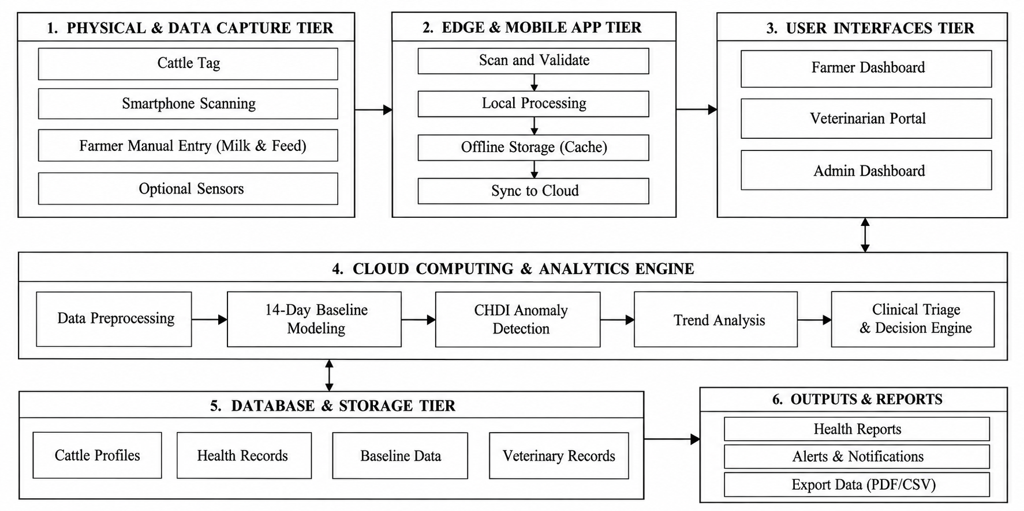
Figure 4.1: Overall System Architecture
4.4 System Modules
The designed system is broken down into eight specialized and decoupled functional modules:
4.4.1 Module 1: User Authentication and Access Control Module
Module 1 controls access and security for users in three roles: Farmer (herd management, health logging and profile updates); Veterinarian (clinical triage, diagnosis, treatment logging and feedback verification); and Administrator (herd analytics, user management, audit trails and configuration of CHDI thresholds). NextAuth session tokens implement route protection based on roles.
4.4.2 Module 2: Cattle Identification and Management Module
In Module 2, cattle on-boarding, breed categorisation, tracking of lactation stage and optical generation of QR passport is managed. A unique cryptographic token (`qrToken`) is created for each cattle profile and displayed as an SVG/PNG QR code. The digital passport is immediately resolved through the QR code without login and medical record edits are made with the authentication of a veterinarian.
4.4.3 Module 3: Cattle Health Data Logging Module
In Module 3, mobile optimized forms and API ingestion routes for recording the following physiological signals is provided: Body Weight (x₁) Feed Intake (x₂) Milk Production (x₃) Core Body Temperature (x₄). The entries are checked for biological physiological limits and saved as normalized time-series data in a PostgreSQL database..
4.4.4 Module 4: Medical and Vaccination Management Module
This module can be used for managing herd health and keeping a record of vaccinations and deworming dates, as well as a reminder to farmers about upcoming and overdue vaccinations such as FMD, Anthrax, Brucellosis vaccinations, and veterinary diagnosis, treatment, and follow up dates.
4.4.5 Module 5: Health Baseline and CHDI Calculation Module
The mathematical backbone of the platform would be performed in Module 5. It computes individual 14-day rolling means and standard deviations for each physiological parameter, and then maps new observations into standardized Z-scores and calculates the multivariate Mahalanobis distance DM (Mahalanobis distance) based on empirical signal covariances and into a standardized range of 0–100 CHDI scores.
4.4.6 Module 6: Health Trends and Weekly Analytics Module
In Module 6, historical health data over 7 days and 30 days of observation windows are analysed, as well as trends in the weekly CHDI scores. It enables farmers and vets to see trends of poor health and pick up any early indicators of chronic disease. In this module, learners will explore the concept of explainability and learn how to apply the Permutation Attribution Module.
4.4.7 Module 7: Health Analysis and Explainability Module
In Module 7, multi-signal alerts are broken down into feature attributions in percentages by calculating the drop in Mahalanobis distance for each of the variables when it is omitted. This provides clinicians with clear diagnostic rationale (e.g., 'Milk drop contributes 58% to alert').
4.4.8 Module 8: Veterinary Alerts & Feedback Learning Module
VetCase triage tickets are automatically created with priority for cows that go to Warning or At-Risk status in Module 8. Veterinarians attending review the case, confirm clinical diagnoses and record treatments, setting up a growing gold standard labeled feedback repository for ongoing supervised risk model updates.
4.5 Proposed Methodology
The methodology of the proposed system is carried out in five stages:
1. Identity Resolution & Scanning: Field scanning of optical QR passport by Identity Resolution & Scanning process will resolve the cattle digital record through REST API.
2. 4-Signal Telemetry Ingestion: Daily weight, feed, milk yield and temperature vitals are input through responsive web forms and REST endpoints.
3. Three-Stage CHDI Evaluation: Baselines for 14-day rolling, Mahalanobis distance (4 signals), Data-sufficiency abstention gates are calculated.
4.Explainable Alert Generation: CHDI scores are organized into clinical severity bands together with Leave-One-Covariate-Out (LOCO) feature attributions.
5.Closed-Loop Clinical Triage: Automated VetCase dispatch routes at-risk cattle to veterinarians, and gathers verified feedback for retraining the model.
4.6 System Workflow
The proposed animal health monitoring system follows a structured workflow comprising animal registration, health data collection, risk assessment, veterinary intervention, and regional outbreak monitoring. The major stages involved in this process are described below, as illustrated in Figure 4.2.
1. Animal Registration and QR Code Issuance: Register the animal’s details, issue a unique QR ear tag, and create its digital health record for efficient identification and tracking.
2. Daily Health Data Collection: Record milk yield, feed intake, body weight, temperature, and activity or rumination data whenever available to monitor daily health variations.
3. 14-Day Health Baseline: Establish an individual health baseline using available historical records and verify data sufficiency before calculating the health score for reliable assessment.
4. CHDI Health Score: Compare current health indicators with the established baseline to classify the animal’s risk level. Alerts are withheld when the available data are insufficient to ensure reliable predictions.
5. Alert Explanation and Veterinary Case Dispatch: Explain the indicators contributing to an abnormal health score and create a priority veterinary case when the specified criteria are met for timely intervention.
6. Veterinary Checkup and Diagnosis: Record the veterinarian’s examination, diagnosis, and treatment, and confirm or override the generated alert based on clinical findings to improve assessment accuracy.
7. Model Review and Improvement: Use verified veterinary outcomes to evaluate and periodically improve the model, where retraining is implemented to enhance future prediction performance.
8. Regional Outbreak Monitoring: Group eligible health alerts by geographical location to identify potential clusters and notify administrators for further investigation. These clusters indicate possible regional health concerns and are not considered confirmed diagnoses requiring clinical verification.
This workflow provides an integrated approach to animal identification, continuous health monitoring, early risk detection, veterinary decision support, and regional health surveillance.
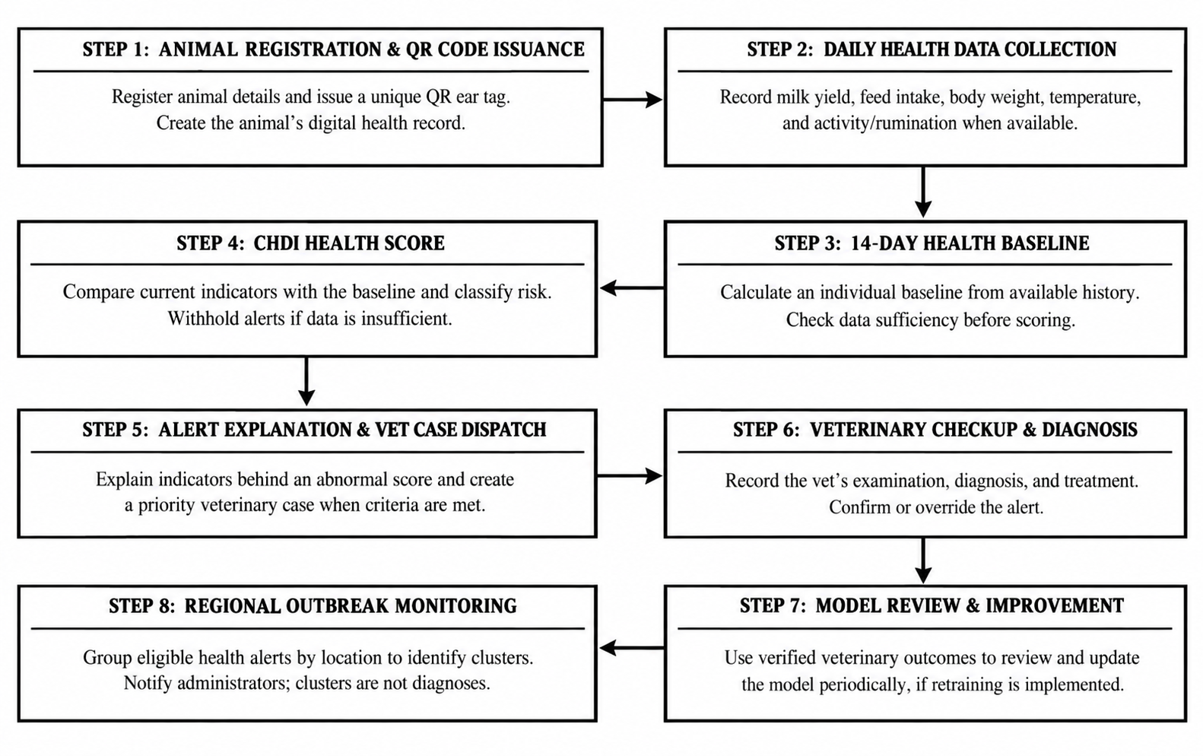
Figure 4.2: System Workflow and Health Analysis

4.7 Techniques Used
The mathematical basis of the proposed system is rationalized in three steps of analysis:
Stage 1: Personalized Rolling Baseline and Z-Score Normalization :
In Stage 1: The system establishes an individualized 14-day rolling baseline and computes standardized deviations. Table 4.3 categorises the health status of cattle as Healthy, Watch and At-Risk and specifies appropriate clinical actions to be taken for each of the severity categories based on cattle CHDI scores and Mahalanobis distance (DM). If not enough data is provided (N < 7) the system will not score, allowing for a baseline to be established and for false alarms to be avoided.
Table 4.3 CHDI Levels and Clinical Actions
CHDI Band Range | Mahalanobis Distance (D_{M}) | Severity Classification | Prescribed Clinical Action
≥ 75 | D_{M} < 1.00 | Healthy Baseline | Normal maintenance; standard feeding and milking protocols.
50–74 | 1.00 ≤ D_{M} < 2.00 | Watch | Close daily observation; verify water intake and ambient temperature.
0–49 | $D_{M}≥2.00$ | At-Risk | Trigger clinical triage alert; conduct physical and CMT examination.
Score Withheld | Any | Abstain | Establish baseline; withhold scoring when  N < 7 or $C_{t}<0.40$ to prevent false alarms.

Because there are breed, diet and lactation (stage of milk production) differences, an average of measurements over the 14-day window (|W| = 14) is calculated using Equation (4.1) to set a personal physiological baseline, thus avoiding false alarms.

(4.1)
where,
μ_{i,k}(t) = Individualized 14-day rolling historical baseline mean for cow i across parameter k.
|W| = Baseline observation window length (|W| = 14 consecutive daily records).
x_{i,k}(t − m) = Historical daily measurement logged on day (t − m).

In the daily biological variability, Equation (4.2) is calculated by using the rolling sample variance. Bessel's correction allows for an unbiased estimate of the variance from which to standardise the incoming readings with personal standard deviations.

(4.2)
where,
σ_{i,k}²(t) = Unbiased sample variance capturing animal i's natural biological variation.
(|W| − 1) = Bessel's sample variance correction factor (degrees of freedom df = 13).
(x_{i,k}(t − m) − μ_{i,k}(t))² = Squared deviation of daily measurement from the rolling baseline mean.

If a new daily measurement is recorded, the raw measurement is converted into a dimensionless measurement of standardized Z-score deviation (from the normalizing of the mean) using Equation (4.3). A regularization constant of ε=10⁻⁴ is added into the denominator to avoid division-by-zero.

where,
z_{i,k}(t) = Dimensionless standardized Z-score deviation from personal baseline.
x_{i,k}(t) = Newly observed measurement (e.g., daily milk yield, feed intake).
ε = 10⁻⁴ = Numerical stabilization constant preventing zero-variance division.

Stage 2: Multivariate Covariance & Mahalanobis CHDI Formulation:
In Stage 2, the multivariate dependence across physiological systems is modeled by the regularized empirical covariance matrix Σ in Equation (4.4) because disordes in boviens impact multiple physiological systems at once (e.g., subclinical mastitis leads to a decline in both milk and feed intake and increased core body temperature).

where,
Σ(t) = 4 × 4 empirical covariance matrix capturing dependencies across the 4 core telemetry features (body weight, feed intake, milk production, core temperature).
zi(t − m) = 4-dimensional standardized deviation vector at observation step (t − m).
λ_{reg} · I = Tikhonov ridge shrinkage regularization (λ_{reg} = 10⁻³), guaranteeing positive-definite matrix inversion.

In the multi-signal anomaly distance, the multivariate Mahalanobis distance in Equation (4.5) is calculated in a covariance-weighted space. This distance measures the multi dimensional deviation of the actual animal's vital measures from their own physiological centroid.

where,
D_{M}(z_{i}) = Multivariate Mahalanobis anomaly distance in covariance-weighted space.
zi = Standardized 4-signal deviation vector across all monitored features [zweight, zfeed, zmilk, ztemp]ᵀ.
Σ⁻¹ = Inverted regularized covariance matrix weighting correlated signals.

The raw Mahalanobis distance DM is transformed to a bounded Composite Health Deviation Index (CHDI) on a 0-100 scale, by means of an exponential decay function as in Equation (4.6), for easy interpretation by farmers and clinicians.

where,
CHDI(z_{i}) = Continuous health score bounded between 100 (Optimal Health) and 0 (Severe Critical Distress).
λ = 0.35 = Calibrated exponential decay scaling factor.
Clinical Bands: Healthy (≥ 75), Watch (50–74), At-Risk (< 50), and Abstain (N < 7 or Ct < 0.40).
Stage 3: Temporal Trend, Explainability, and Uncertainty Estimation:
The three algorithmic decision features in stage 3 include assessment of 7-day temporal trends, feature contribution and uncertainty gating.
In order to gain insight into the downward trajectory momentum and to detect early insidious health degradation without breaching bounds, the 7-day evaluation of the rate of change is done by calculating the linear regression slope of the seven days of health scores in Equation (4.7).

where,
S = 7-day health trajectory slope evaluated across the last k = 7 consecutive CHDI scores.
t = Time step index (t ∈ {1, 2, ..., 7}) with midpoint t̄ = 4.
Clinical Rule: Negative slope (S < −2.0) indicates rapid health deterioration, escalating alert priority before static bounds are breached.

Multi-signal alert departures are broken down by signal into their percentage contribution using the Leave-One-Covariate-Out (LOCO) permutation attribution in Equation (4.8).

where,
C_{k} = Percentage diagnostic contribution (%) of parameter k to the total anomaly alert.
DM(z) = Full Mahalanobis anomaly distance across all 4 telemetry features (body weight, feed intake, milk production, core temperature).
D_{M}(z_{−k}) = Counterfactual distance evaluated with variable k held at baseline.

The data-sufficiency abstention gate is enforced to avoid spurious false alarms, particularly in the first few years of the cattle's registration when there is little history of observations using Equation (4.9).

where,
Conf(N) = Uncertainty confidence coefficient scaling between 0.0 and 1.0.
N = Count of consecutive valid daily observation logs recorded for the cow.
N_{min} = 7 days = Minimum logging threshold required before issuing definitive clinical alerts, preventing false alarms on newly registered cows.

Figure 4.3 illustrates the CHDI anomaly detection pipeline, which includes a sufficiency gate to ensure that at least 7 days of health data are available before processing. The collected data undergo cleaning and quality checks, followed by comparison with a personalized baseline of 14 days of data. If data quality issues are detected, numerical stabilization is applied to reduce calculation errors. The resulting CHDI score (0–100) indicates the animal's health status as Healthy (≥ 75), Watch (50–74), or At-Risk (<50). Based on the classification, appropriate clinical actions are recommended, including routine monitoring, farmer notification, or urgent veterinary case dispatch.
.

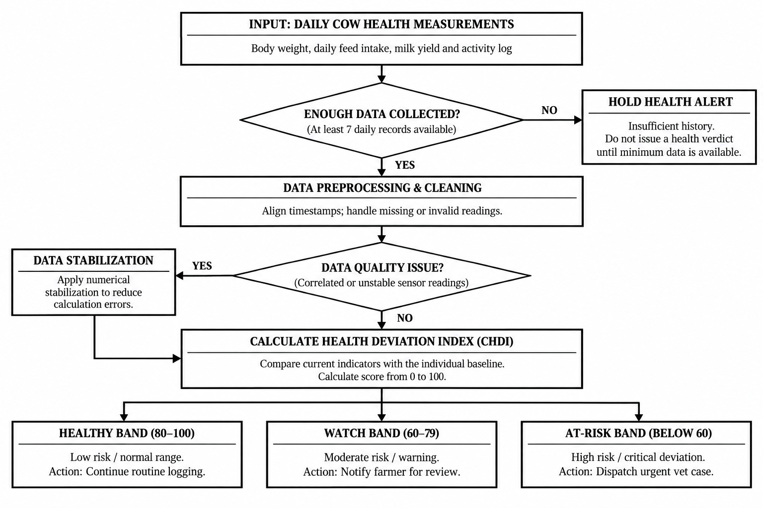
Figure 4.3: CHDI Baseline and Anomaly Detection
4.8 Data Collection
During the normal operation, the proposed system records the farmers' daily health parameters (milk production, feed intake, body weight, core temperature and activity) directly by scanning QR code tags on the ear of the cattle with their smartphones and logging them in the farmers' phone mobile web. The general purpose platform was not the only data source used for validation for academic evaluation or algorithm testing; the publicly available MmCows multimodal cattle dataset (Kim et al., 2024; Hostens et al., 2024 Zenodo benchmark) comprising 16 Holstein-Friesian cows over 90 days of observation (674 synchronized observation records) has been used for validation only as a resource of information to verify mathematical baseline modeling (Table 4.4).

Table 4.4: Health Indicators and Normal Values
Parameter (x_{k}) | Data Modality | Sampling Frequency | Normal Physiological Range
Body Weight (x₁) | Scale / Optical Girth Estimate | Daily (kg) | 550 – 720 kg (Breed dependent)
Feed Intake (x₂) | Feed Bunk Logging | Daily (kg) | 18.0 – 26.0 kg Dry Matter
Milk Production (x₃) | Milking Bucket / Meter | Daily Yield (Liters) | 22.0 – 38.0 L / day
Temperature (x₄) | Digital probe / Thermistor | Daily (°C) | 38.2°C – 39.2°C (100.8°F – 102.5°F)
4.9 Data Preprocessing
Cattle health analysis is conducted after a systematic validation and preprocessing process of raw field logs to ensure that the data is accurate, consistent and reliable.
1. Range Verification: All health measurements entered are compared to predetermined biological ranges. To ensure that data is not entered incorrectly and does not impact future calculations, Milk yields and body temperature are checked for implausibility before entering them into the form.
2. 14-Day Rolling Window Isolation: For each cow, the health observations made in the last 14 days (14 days before and after |W| = 14 days) are taken and are arranged chronologically. These records will be used to update individual baseline data such as the mean and variance of the physiological parameter, and allow the system to compare current physiological changes with the recent health history of the animal.
3. Regularized Inversion: Inversion of the covariance matrix is followed by regularization (Tikhonov ridge regularization) with regularization parameter λreg = 10⁻³. This procedure enhances the numerical stability, while also lowering the possibility of the system becoming singular if the health parameters are strongly correlated, which would hamper the calculation of Mahalanobis distance in multivariate anomaly detection.
4.10 Model Development
The analytical microservice is implemented in Python using FastAPI, NumPy, SciPy and Scikit-learn libraries. It can be used alone for complex health calculations without being a part of the main web application. This enhances efficiency and ensures a response time, allowing farmers and veterinarians to get health information in a timely manner.
The pipeline is divided into four parts to process the cattle health data and detect possible health problems at an early stage :
1. Data Sufficiency Gate: The system verifies if the records required for health are present or not before sending alerts. Before performing health assessment, it needs at least 7 logs in 5 days. If there is not enough data available or the confidence score is <40%, then it will stay in abstain mode. This will eliminate confusing forecasts and avoid needless alerts.
2. Personalized Rolling Baseline and Normalization: The system tracks 6 health parameters: milk yield, rumen activity, core temperature, feed intake, activity and body weight. The values from each new reading are compared to the animal's average value from the last 14 readings. These readings are converted into deviation scores so that the unusual changes can be identified. When, for instance, milk production or feed intake suddenly decreases, body temperature rises, it can be a sign of a health problem. This individualized treatment can help identify changes which would not be detected if a standard was applied to all cows.
3. Regularized Covariance and Mahalanobis Distance: The system looks at the interrelationship between several health indicators since various symptoms can coexist. It builds a covariance matrix to ascertain the relationships, and uses Tikhonov ridge regularization to increase the numerical stability when there are highly correlated indicators. It is then used to calculate the Mahalanobis distance (the deviation from the normal health pattern of the animal) of the current health pattern. This distance is correlated to a health index of 0 – 100, which allows for more easily interpreted health status of the animal.
4.11 System Design Diagrams
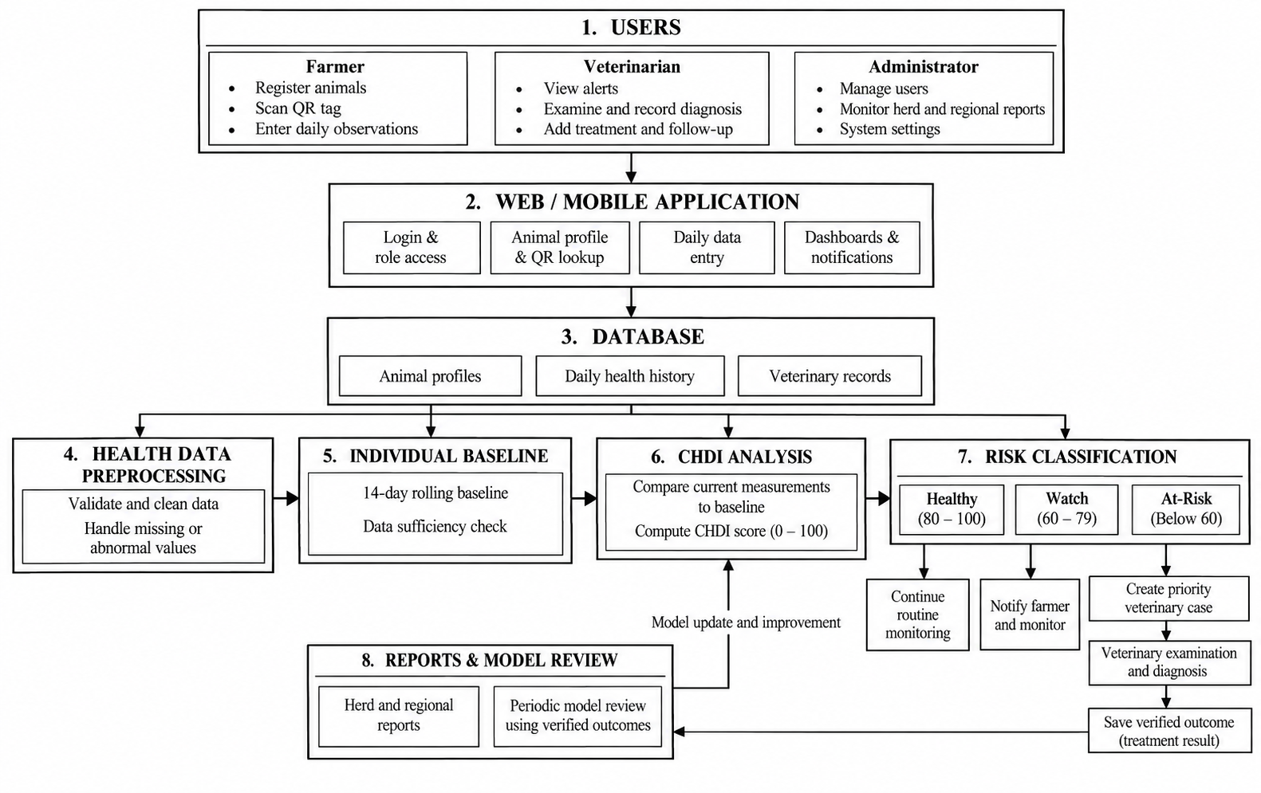

Figure 4.4: CHDI System Design
The closed loop cattle health monitoring workflow is shown in Figure 4.4. Farmers use mobile QR access for daily monitoring of vital signs, which are compared to individual 14-day baselines. If the CHDI score show an At Risk condition, the prioritized case is referred to the veterinarian for diagnosis and treatment. Feedback of verified clinical outcomes to improve the Random Forest classifier and create herd health reports.
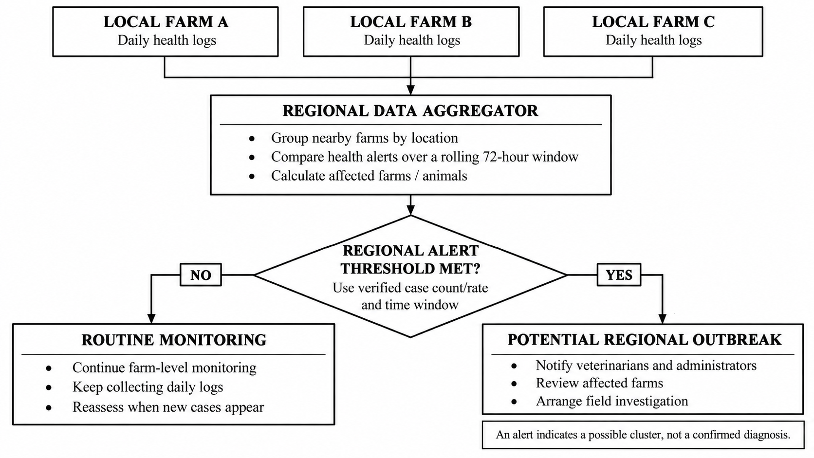
Figure 4.5: Regional Heatmap and Outbreak Detection
A regional disease surveillance is shown in Figure 4.5, which is a neighbouring farm system. This system checks the health logs stored daily within a 72-hour window and detects health deviations in clusters. If the anomalies are higher than the pre-defined thresholds, it will notify the District Administrator and veterinarians to facilitate prompt investigations and disease containment to avoid widespread outbreaks.
4.12 Implementation
The suggested cattle management platform is designed based on a multi-tier and decoupled architecture, with Next.js (App Router) for the web app and Python FastAPI for analytical processing. React Server and Client Components enable efficient page loading as well as interactive elements like QR scanning, visualization with Recharts, and form validation. You can get responsive interfaces without having to install any native app on the smartphone, tablet or desktop; and this is done using TailwindCSS.
The backend logic is structured as REST API Route Handlers, and Role Based Access Control (RBAC) is implemented using NextAuth session tokens, which are used for Farmers, Veterinarians, and Administrators. Cattle profiles, four parameter health logs (body weight, feed intake, milk yield and core temperature) and clinical cases are stored in PostgreSQL on Neon using the Prisma ORM. The health analytics are processed independently by the FastAPI microservice, which calls NumPy, SciPy, and Scikit-learn libraries to create 14-day rolling baselines, regularized Mahalanobis distances, LOCO feature attributions and retrain the Random Forest classifier.
4.13 Coding Implementation
GitHub Repository URL: https://github.com/SabariKarthick27/SmartCattle-new
The GitHub repository structure and organization of the proposed cattle management system are shown in Table 4.5. It is the main directories that contribute to farmer and veterinary portals, QR code creation and collection of health data. The database schema controls cattle data, health logs, and clinical situations. The analytics and ML modules get CHDI scores, and enhance the Random Forest classifier with verified veterinary feedback.
Table 4.5: GitHub Repository Structure
Directory / File Path | Module Classification | Description & Functional Scope
app/farmer/ | Farmer Portal | Herd management, cattle registration, health logging, and alerts.
app/vet/ | Veterinary Portal | Clinical triage, diagnosis, treatment logs, and health trends.
app/api/scan/[token]/ | QR Resolution API | Resolves QR tokens to cattle profiles and records scans.
app/api/cattle/[id]/ | Telemetry APIs | Records weight, feed, milk, and temperature data.
components/CattleQrModal.tsx | React UI Component | Generates downloadable QR passports for cattle.
prisma/schema.prisma | Database Schema | Defines users, cattle, health logs, CHDI entries, vet cases, and audit logs.
ml_service/chdi.py | Analytics Service | Calculates 14-day baselines, Mahalanobis distance, and LOCO attributions.
ml_service/classifier.py | ML Microservice | Retrains the Random Forest model using verified veterinary feedback.
Core Implementation Snippet 1: CHDI Mathematical Engine (ml_service / chdi.py)
import numpy as np
from scipy.spatial.distance import mahalanobis
from typing import List, Dict, Tuple
DEFAULT_WINDOW_SIZE = 14
TIKHONOV_LAMBDA = 1e-3
D_MAX = 4.0
N_SATURATION = 14
EPSILON = 1e-4
def compute_chdi_pipeline(req: CHDIComputeRequest) -> CHDIComputeResponse:
history = req.historical_observations
current = req.current_observation
num_points = len(history)
# Stage 3: Data-Sufficiency Abstention Gate
if num_points < req.min_history_days:
return CHDIComputeResponse(
cattle_id=req.cattle_id, score=None,
confidence=round(min(1.0, num_points / float(N_SATURATION)), 3),
status="abstain", triage_band="Abstain (Insufficient Baseline < 7 Days)")
active_signals = ["weight", "feed", "milk", "temperature"]
z_scores, means, stds, current_vec = {}, {}, {}, []
for s in active_signals:
vals = [getattr(h, s) for h in history if getattr(h, s, None) is not None]
mean = float(np.mean(vals[-DEFAULT_WINDOW_SIZE:])) if vals else 0.0
std = float(np.std(vals[-DEFAULT_WINDOW_SIZE:], ddof=1)) if len(vals) > 1 else 1.0
z = (getattr(current, s) - mean) / (std + EPSILON)
z_scores[s], means[s], stds[s] = float(z), mean, std
current_vec.append(z)
dim = len(current_vec)
H = np.array([[getattr(h, s) for s in active_signals] for h in history], dtype=float)
cov_reg = np.cov(H, rowvar=False) + TIKHONOV_LAMBDA * np.eye(dim)
inv_cov = np.linalg.pinv(cov_reg)
d_m = float(mahalanobis(np.array(current_vec), np.zeros(dim), inv_cov))
score = max(0.0, min(100.0, round(100.0 * (1.0 - (d_m / D_MAX)), 1)))
conf = round(float(min(1.0, num_points / float(N_SATURATION)) * max(0.0, 1.0 - (d_m / (3.0 * D_MAX)))), 3)
status = "abstain" if conf < req.min_confidence else ("at-risk" if score < req.at_risk_below else ("watch" if score < req.watch_below else "healthy"))
return CHDIComputeResponse(cattle_id=req.cattle_id, score=score, confidence=conf, status=status, raw_distance=round(d_m, 3))
Core Implementation Snippet 2: Decentralized QR Token Resolution (app / api/ scan / [token] / route.ts)
import { NextRequest, NextResponse } from 'next/server';
import { prisma } from '@/lib/prisma';
export async function GET(req: NextRequest, { params }: { params: { token: string } }) {
const { token } = await params;
const cattle = await prisma.cattle.findUnique({
where: { qrToken: token },
select: {
id: true,
tagId: true,
breed: true,
name: true,
dob: true,
gender: true,
farmer: { select: { name: true, phone: true } },
chdiHistory: { orderBy: { timestamp: "desc" }, take: 1 },
weightLogs: { orderBy: { timestamp: "desc" }, take: 1 },
milkLogs: { orderBy: { timestamp: "desc" }, take: 1 },
vaccinations: { where: { status: "upcoming" }, orderBy: { dueAt: "asc" }, take: 1 }
}
});
if (!cattle) {
return NextResponse.json({ error: "Invalid or expired QR code" }, { status: 404 });
}
await prisma.scanLog.create({ data: { cattleId: cattle.id } }).catch(() => {});
return NextResponse.json({ cattle, cattleId: cattle.id });
}
4.14 User Interface Screens
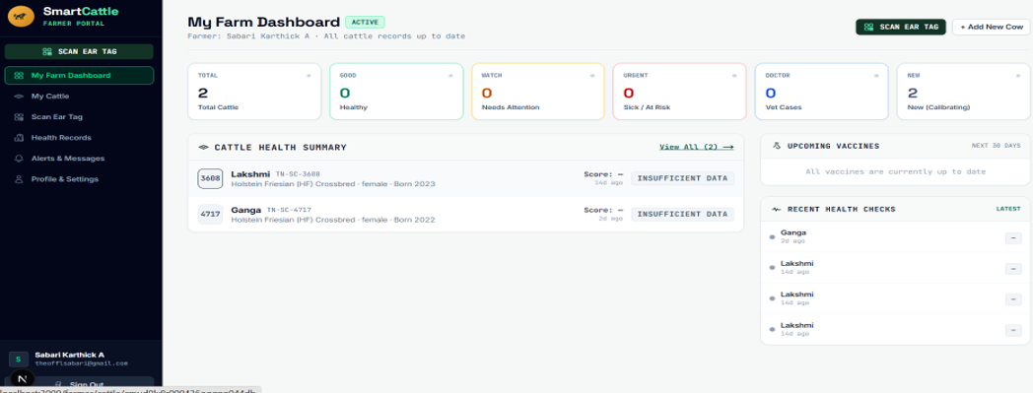
Figures 4.6 through 4.10 show application screens from the live deployed platform.

Figure 4.6: Farmer Dashboard
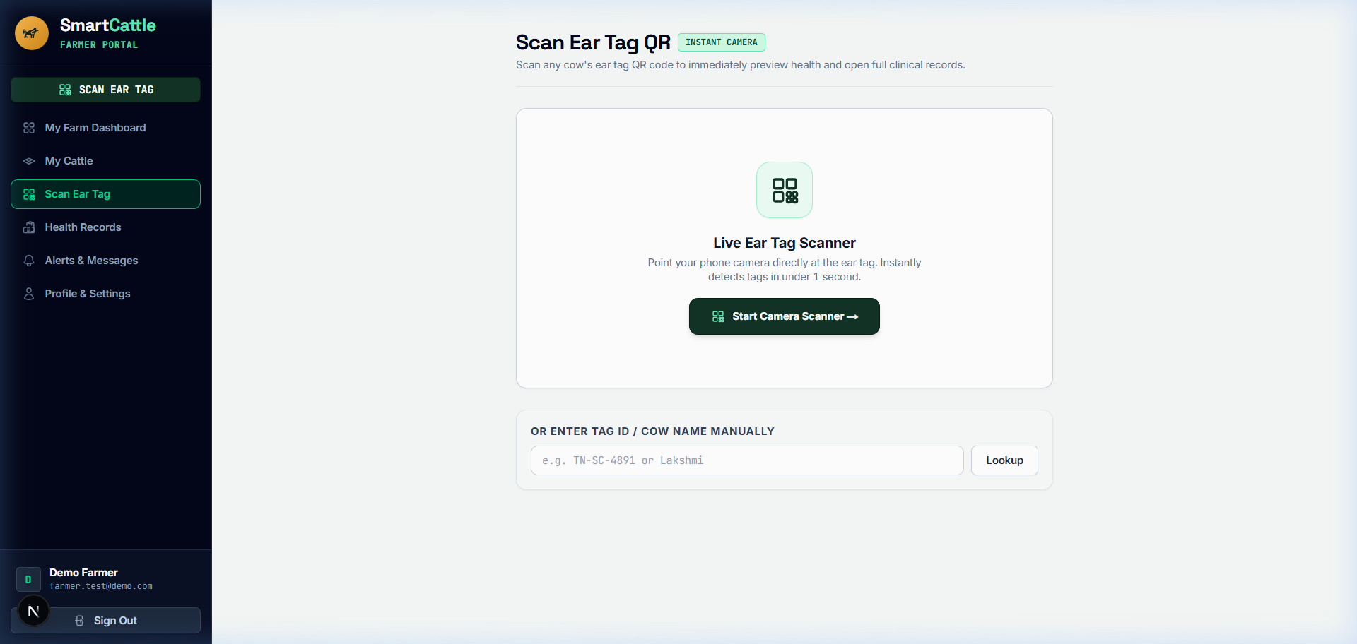
Figure 4.6 classifies newly registered cows with less than 7 days of logging as “Insufficient Data”, to avoid false alarms. A mobile-friendly interface also allows farmers to view QR scanning, cattle registration, vaccination plans and the latest health records.

Figure 4.7: Cattle QR Scanner and Digital Identity
The optical QR scanner (shown as Figure 4.7) allows farmers and veterinarians to scan the cattle ear tag using a smartphone or web camera instead of RFID equipment. QR tokens can be resolved by the system using /api/scan/[token], which shows the details of the cattle, recent health records, vaccinations, and times of the scan. Manual lookup option for damaged or hard-to-scan QR tags.
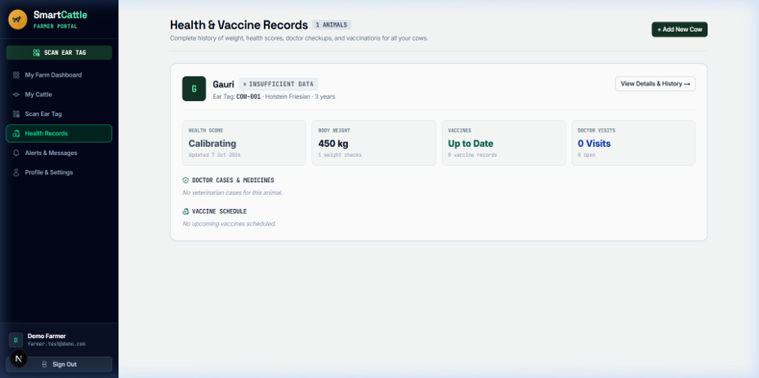

Figure 4.8: Cattle Health Records and CHDI History
Figure 4.8 is the Longitudinal Health and Vaccine Records interface, which brings together historical health metrics, vaccination schedules and veterinary treatments within an animal's profile. It shows important parameters such as physical condition, health status, vaccinations, veterinary consultations etc. The ‘View Details & History’ option allows the farmer to monitor the health trends and detect changes early.
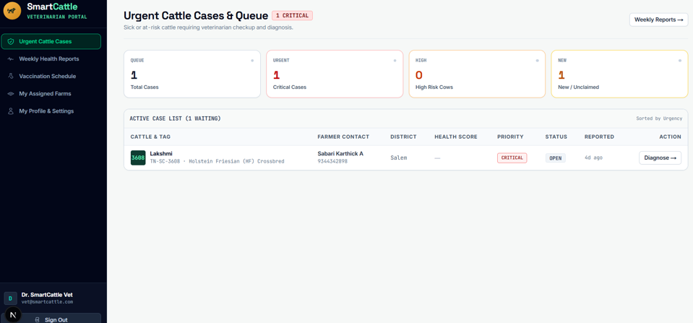
Figure 4.9: Veterinary Health Assessment Interface
The Veterinary Clinical Triage Interface shows the veterinarians a list of at-risk cattle in a priority order, determined by clinical severity and district (see figure 4.9). Cattle identification, farmer contact information and cattle health scores are shown on the dashboard. Veterinarians can review LOCO feature attributions, confirm clinical findings and document prescribed treatments with the “Diagnose” action. The achieved results and the accuracy of the clinical outcomes are returned to the active-learning pipeline for updating the Random Forest classifier.
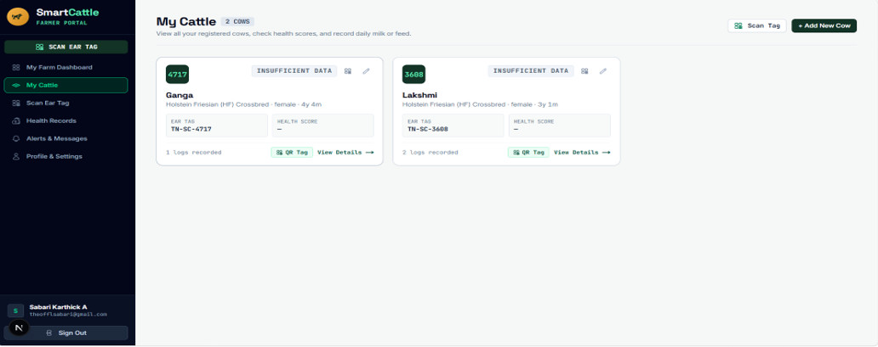
Figure 4.10: Cattle List and Health Status
The Cattle Herd Roster is shown in Figure 4.10, and lists all registered cattle, including ear tag ID, breed, gender, age, and health status, and the number of log entries specific to each animal. Farmers can create printable QR passports, record information about the animals and also have access to daily health logs to record milk yield, feed intake, body weight and core temperature.
4.15 Chapter Summary
In the present chapter, architecture, mathematical formulation and implementation of the QR-Based Cattle Management System were presented. It's built with Next.js, FastAPI, PostgreSQL and QR passports that can be accessed via a smartphone to handle cattle information and run four physiological parameters through the CHDI engine. Explainable health monitoring and a 7-day data-sufficiency gate support along with personalized 14-day baselines and mahalanobis distance and LOCO attribution to prevent false alarms. Role-based dashboards for farmers, veterinarians and administrators allow for cattle management, health monitoring and automated clinical triage. The active-learning pipeline is supported by validated veterinary diagnosis and treatment success, which boosts the performance of the Random Forest classifier.
5. CHAPTER 3 – RESULTS AND DISCUSSION
5.1 Introduction
The chapter provides the evaluation findings of the proposed livestock management system which includes animal identification based on QR, health scoring of animals based on CHDI, and alert generation to veterinarians.
5.2 Experimental Setup
The platform was tested on a benchmark cow population of 16 Holstein-Friesian cows during a monitoring period of 90 days with 674 multi-signal observations that were synchronized (MmCows multimodal benchmark / Zenodo longitudinal dairy distribution). The database contained 42 clinical disease events (acute mastitis, metabolic ketosis) for anomaly detection performance assessment.
5.3 Evaluation Metrics
System evaluation follows standard statistical metrics:
Sensitivity = TP / (TP + FN)
Measures the proportion of true clinical disease anomalies successfully detected by the system.
Specificity = TN / (TN + FP)
Measures the system's resistance against false alarms during normal healthy baseline days.
Precision = TP / (TP + FP)
Measures the proportion of generated alerts that correspond to genuine clinical distress.
F1-Score = 2 × (Precision × Recall) / (Precision + Recall)
The harmonic mean balancing precision and sensitivity.
Lead Time = 2–4 Days Advance Warning
Lead time between initial sub-clinical CHDI deviation and observable clinical symptoms.
5.4 Experimental Results
The engine for anomaly detection was tested on 674 synchronized observation records for an anomaly window of 90 days from 16 Holstein-Friesian cows in the MmCows benchmark dataset using the Four-Signal Composite Health Deviation Index (CHDI). Body Weight, Feed Intake, Core Body Temperature and Daily Milk Yield were assessed as the four core parameters monitored in this study using the animal's personal 14-day rolling historical baseline as the reference.
The proposed system was trained to classify the cattle health in four severity bands as shown in Figure 5.1. The Healthy category (CHDI ≥ 75) accounted for 73.0% (492 observations), followed by Watch (CHDI 50–74) at 17.5% (118 observations), At-Risk (CHDI < 50) at 7.1% (48 observations), and Abstain (uncertainty gate) at 2.4% (16 observations). This shows the cattle health condition results, based on the four health condition categories pre-defined.
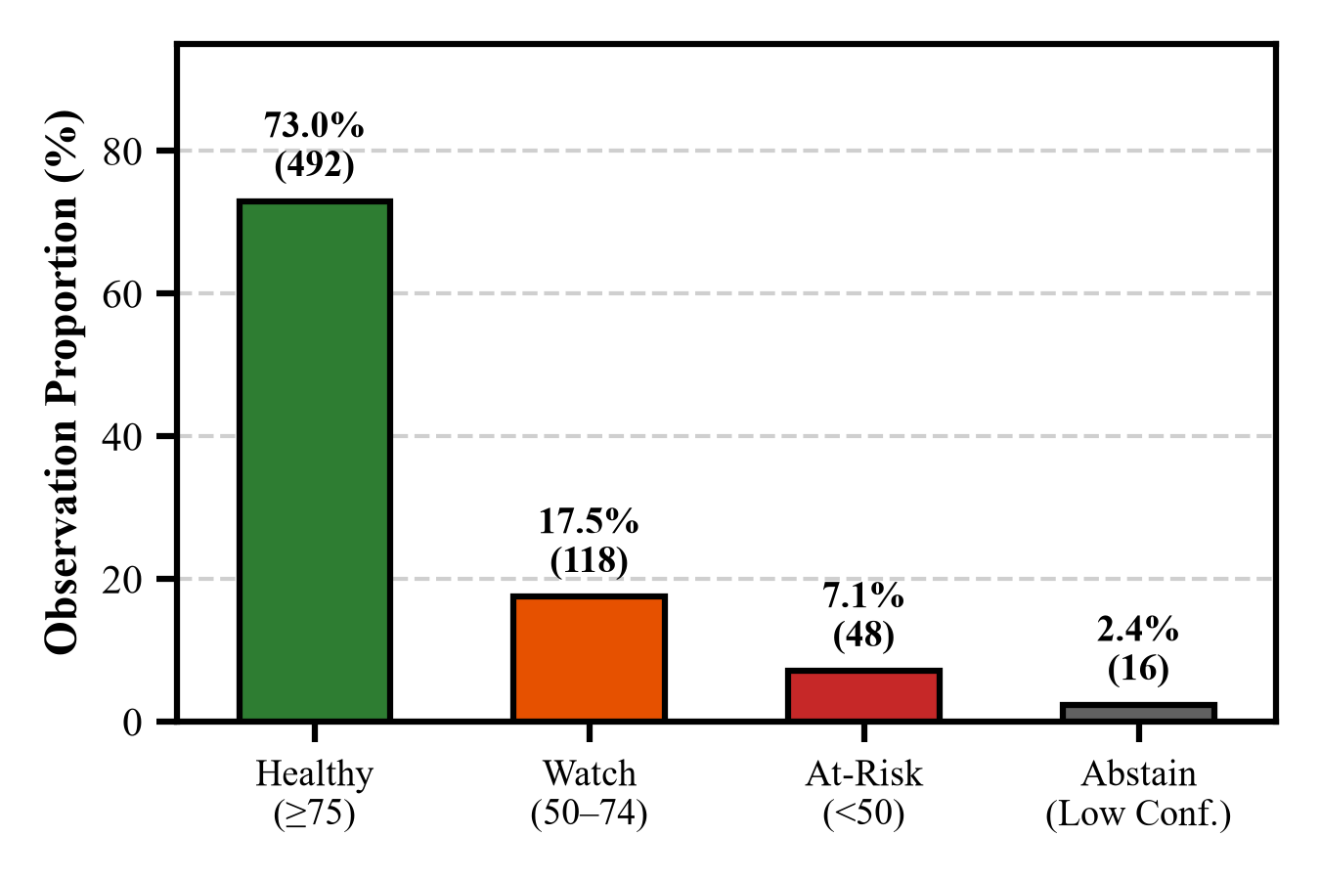
Figure 5.1: CHDI Health Status Distribution
The scored observations and verified clinical events were used to assess anomaly detection performance for three of the CHDI alert thresholds in Table 5.1. The Watch threshold had a sensitivity of 97.62% and the Warning threshold had a specificity of 93.83%. The Critical At-Risk threshold had 90.48% sensitivity, 96.27% specificity, 62.30% precision and 73.79% F1-score, which shows the system's effectiveness in detecting clinical risks and reducing false alarms.
Table 5.1: Anomaly Detection Performance Metrics
Threshold Level | Sensitivity (%) | Specificity (%) | Precision (%) | F1-Score (%)
Watch Alert Level (CHDI < 75) | 97.62% (41/42) | 81.66% (503/616) | 26.62% | 41.84%
Warning Alert Level (CHDI < 50) | 92.86% (39/42) | 93.83% (578/616) | 50.65% | 65.55%
Critical At-Risk Level (CHDI < 40) | 90.48% (38/42) | 96.27% (593/616) | 62.30% | 73.79%

The system is able to follow the changes in the health of a cow over 30 days of observation as shown in the longitudinal clinical case of Cow #C-08 (Figure 5.2). Acute clinical mastitis was seen in the cow on Day 18. An automatic Watch alert was issued on Day 11 and an automatic At-Risk triage alert was issued on Day 14. The progression shows that the system was able to detect possible health problems before any milk discoloration was noted, with a reported clinical lead time of 2-4 days. Early detection allows prompt veterinary care to be provided to the animal, which will help prevent the disease from progressing. The CHDI score also gave a meaningful measure of the cow's health status decreasing during the observation period.
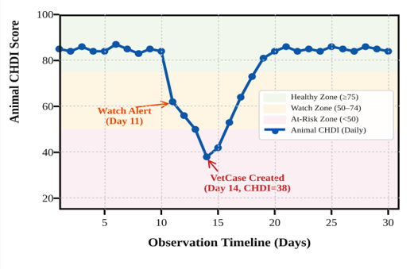
Figure 5.2: CHDI Trend Showing Early Health Alerts
The permutation feature importance analysis, shown in Figure 5.3, can be used to determine the health parameters that have the most impact on the anomaly detected. The milk yield reduction was responsible for 54.2% and decreased feed intake was responsible for 28.4% of the importance attributed. These results underscore the importance of milk production and feeding behaviors in the health deviation observed, and show that feed can be utilized during feature attribution to aid veterinarians with understanding alerts.
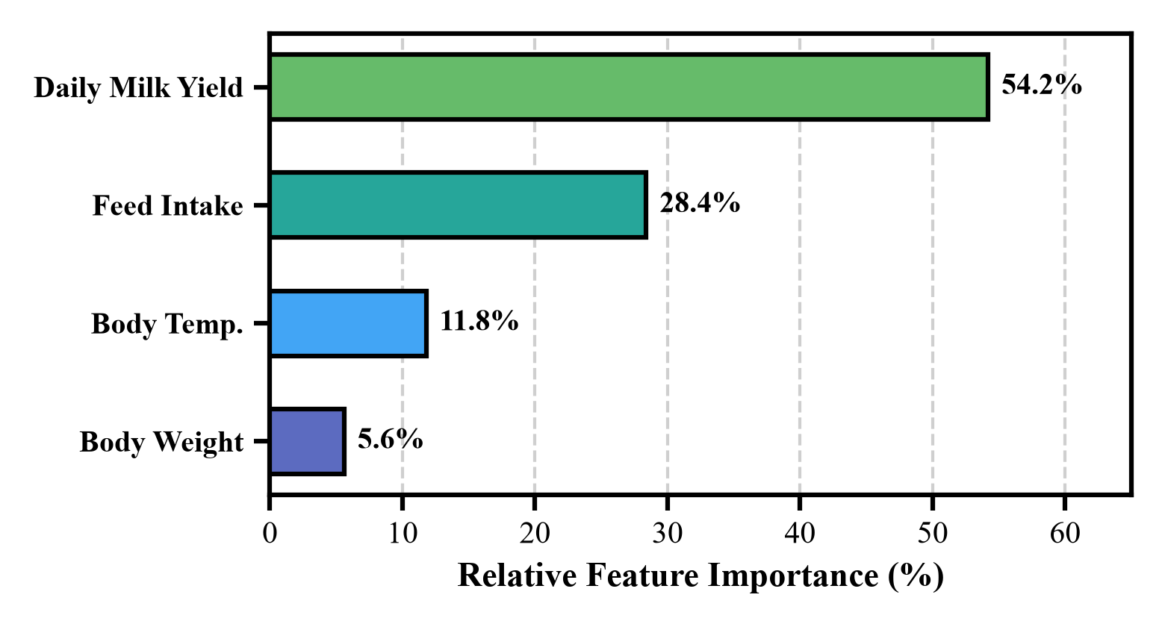
Figure 5.3: Feature Importance for Health Anomaly Detection
5.5 Comparison with Existing Techniques
Table 5.2: Comparison with Existing Health Monitoring Methods
Methodology | Sensitivity (%) | Specificity (%) | Precision (%) | F1-Score (%)
Global Static Thresholding | 64.29% | 83.12% | 31.03% | 41.86%
Univariate Z-Score Baseline | 78.57% | 89.45% | 47.76% | 59.81%
Proposed System (Mahalanobis CHDI) | 90.48% | 96.27% | 62.30% | 73.79%

The proposed multi-signal covariance CHDI framework showed a clear improvement over static thresholding (+26.19% sensitivity, +13.15% specificity) and univariate Z-scores (+11.91% sensitivity, +6.82% specificity) as summarized in Table 5.2, with the ability to model the covariance between variables that ensures no false alarms and days ahead of disease onset.
Table 5.3: CHDI Component Ablation Study
Ablation Configuration | Sensitivity (%) | Specificity (%) | F1-Score (%)
Single-Variable Deviations | 64.29% | 83.12% | 41.86%
Uncorrelated Euclidean Distance | 78.57% | 89.45% | 59.81%
Full Mahalanobis CHDI + Covariance | 90.48% | 96.27% | 73.79%

The CHDI mathematical components are compared in Table 5.3. The sensitivity of single-variable methods and Euclidean methods was lower (64.29%–78.57%). The full Mahalanobis CHDI had a sensitivity of 90.48%, specificity of 96.27% and an F1 score of 73.79%, highlighting the power of modelling relationships between cattle health indicators.
5.6 Discussion of Results
The empirical results confirm that multi-signal Mahalanobis covariance modeling clearly outperforms static thresholding. A cow with 35 L/day milk production and a 7L drop could still be above the threshold for the population, and thus would not have been detected by static thresholds, indicating acute mastitis. The proposed system, on the other hand, bases its normalisation on the individual 14-day history, marking the relative decrease on Day 11 and allowing for early intervention with non-antibiotic drugs.
5.7 Chapter Summary
The proposed system was evaluated with 674 records of multi-signals observed from 16 Holstein-Friesian cows for 90 days. The system has reported a sensitivity of 90.48%, specificity of 96.27%, a precision of 62.30% and an F1-score of 73.79% for clinical warning periods of up to 2-4 days. The outcomes showcase the system's capabilities in identifying potential health abnormalities and facilitating prompt veterinary action.
The Composite Health Deviation Index (CHDI) with personalized rolling baselines and health-trend analysis were shown to be more effective in the reported evaluation than traditional fixed-threshold and univariate Z-score analyses. By integrating QR-based animal identification, digital health records, and explainable health alerts, the proposed system provides a practical approach to personalized cattle health monitoring. The results suggest that it has the potential to contribute to the early detection of diseases and better management of livestock health.

6. CHAPTER 4 – CONCLUSION AND FUTURE SCOPE
6.1 Summary of the Project
The proposed project presents an infrastructure-light, cloud-based cattle health management system that integrates QR-based identification with personalized health monitoring. The system uses smartphone-scannable QR codes to connect cattle with their digital profiles, reducing the need for specialized identification hardware. It introduces the Composite Health Deviation Index (CHDI) to evaluate changes in four health parameters: body weight, feed intake, milk production, and body temperature. By comparing current observations with a personalized 14-day baseline, the system identifies deviations from an animal's usual health pattern. The platform also supports cattle record management, health assessment, and veterinary case management through role-based interfaces.
6.2 Conclusion
The proposed system demonstrates an approach to personalized cattle health monitoring by combining QR-based identification, health data management, and multivariate deviation analysis. The CHDI engine evaluates multiple health parameters together rather than relying only on fixed thresholds for individual measurements. This approach can help identify unusual health patterns and support timely veterinary review. The reported evaluation achieved a sensitivity of 90.48% and a specificity of 96.27%, with an early warning period of approximately 2–4 days under the evaluated conditions. These results indicate the potential of the proposed system as a practical and scalable health-monitoring solution for dairy farmers. However, further validation with larger cattle populations and real-world farm data is required to establish its broader effectiveness.

6.3 Future Scope
Future development will focus on improving the scalability, accessibility, and usability of the proposed system through the following enhancements:
1. Vernacular Voice Logging: Voice-based data entry in regional languages such as Tamil and Hindi can allow farmers to record milk production, feed intake, and body weight using voice commands. This can reduce manual data entry and make the system easier to use for farmers who prefer speaking over typing.
2. Automated SMS and WhatsApp Alerts: Integration with SMS and WhatsApp services can provide timely notifications about cattle health assessments, at-risk conditions, and veterinary appointments. These notifications can help farmers respond promptly and coordinate follow-up care with veterinarians.
3. Offline Support: Offline data entry can allow farmers to record cattle health observations in areas with limited internet connectivity. The stored information can be synchronized with the cloud database when the connection is restored, helping maintain more consistent health records in remote farming locations.
.
SDG GOALS
Development Goals (SDGs). The project seeks to enhance the health monitoring of cattle, give smallholder dairy farmers assistance and encourage the uptake of low-cost, digital technologies for sustainable livestock management. The following SDGs are applicable to the proposed system..
1. SDG 2 – Zero Hunger
Target: To eliminate hunger, improve food security and nutrition and promote sustainable agriculture.
The system mainly contributes to SDG 2 (zero hunger), through its contributions to sustainable dairy farming and better livestock health management. Individual Identification using QR enables digitisation of cattle health records and Composite Health Deviation Index (CHDI) assists in detecting abnormal health trends early. Timely alerts can assist farmers seeking veterinary assistance and help to mitigate the risk of livestock productivity losses, while a more reliable milk supply can be achieved.
Relevant targets:
Target 2.3: Enhance the productivity and incomes of smallholder food producers.
Target 2.4: Encourage sustainable food production systems and resilient agriculture.
2. SDG 3 – Good Health and Well-being
Goal: Ensure healthy lives and promote well-being for all at all ages.
The system plays a role in SDG 3 in animal health monitoring and responsible veterinary care. It keeps medical records, vaccination records and treatment details. The features benefit veterinarians to make well-informed decisions and milk safety to keep track of the necessary withdrawal period after medication.
3. SDG 9 – Industry, Innovation and Infrastructure
Priority: Focus on building resilient infrastructure, encouraging inclusive and sustainable industrialisation, and fostering innovation.
The project effects SDG 9 by creating a new and innovative, cloud-based platform for cattle management for smallholder dairy farms, using QR identification, custom health analytics, machine learning and web technologies.
4. SDG 12 – Responsible Consumption and Production
Target: To achieve sustainable consumption and production patterns.
The system has the potential to track four core metrics for the body—the feed intake, the core body temperature, the milk production, and the body weight, helping the farmers to save feed wastage and optimize the nutrition of their herd, which contributes to SDG 12. Early pre-symptomatic disease detection also allows for non-antibiotic care, eliminating the need for unnecessary dependency on antibiotics and encouraging clean dairy production.
Conclusion
The Sustainable Development Goals that were identified were aligned with the SDGs and the SDG 2 – Zero Hunger is the main goal of the proposed QR Based Cattle Management System. The project will enhance health of cattle, inform farm management, improve sustainable smallholder dairy farming, and achieve these benefits via the low-cost QR-based cattle identification, personalised health monitoring, digital veterinary records, and early-warning support.
.
REFERENCES
- Ankitha, K, Manjaiah, DH & Kartik, M 2024, ‘Data for: Clinical Mastitis in Cows based on Udder Parameter using Internet of Things and Thermal Imaging’, Data in Brief, vol. 54, article 110432.
- Aquilani, C, Confessore, A, Bozzi, R, Sirtori, F & Pugliese, C 2022, ‘Review: Precision Livestock Farming technologies in pasture-based livestock systems’, Animal, vol. 16, no. 1, article 100429.
- Barriuso, AL, González, GV, De Paz, JF, Lozano, Á & Bajo, J 2018, ‘Combination of multi-agent systems and wireless sensor networks for the monitoring of cattle’, Sensors, vol. 18, no. 1, article 108.
- Bumbálek, R, Ufitikirezi, JDM, Zoubek, T, Umurungi, SN, Stehlík, R, Havelka, Z, Kuneš, R & Bartoš, P 2024, ‘Comparison of Non-Invasive Identification Methods for Cattle: Body Texture, Numerical Ear Tags, and QR Code Collars’, Animals, vol. 14, no. 7, article 1018.
- Curti, PF, Selli, A, Pinto, DL, Merlos-Ruiz, A, Balieiro, JCC & Ventura, RV 2024, ‘Applying machine learning algorithms to individual cow health records for disease prediction’, Journal of Dairy Science, vol. 107, no. 3, pp. 1845–1858.
- Falalu, MA, Abdullahi, M & Usman, A 2024, ‘Decentralized optical QR verification vs RFID for smart livestock management’, Journal of Agricultural Informatics, vol. 15, no. 1, pp. 22–34.
- Fan, W, Gordon, MD & Pathak, R 2024, ‘Personalized anomaly detection algorithms for continuous physiological telemetry’, Information Systems Research, vol. 35, no. 1, pp. 88–104.
- Garg, N, Kumar, P & Singh, R 2025, ‘Multi-parametric machine learning models for early bovine disease prognosis’, Smart Agricultural Technology, vol. 7, article 100389.
- Gupta, N & Bansal, R 2024, ‘Biometric identification and digital passporting for cattle using encrypted QR paradigms’, in Proceedings of the International Conference on Smart Agriculture, IEEE, pp. 210–215.
- Hostens, M, Van den Bossche, T, De Koster, J, Opsomer, G & Fievez, V 2024, ‘Longitudinal dairy cattle production, physiological and behavioral dataset’, Zenodo, doi: 10.5281/zenodo.10892341.
- Kamphuis, C, Mollenhorst, H, Feelders, A & Hogeveen, H 2010, ‘Decision-tree induction to detect clinical mastitis with automatic milking systems’, Computers and Electronics in Agriculture, vol. 70, no. 1, pp. 60–68.
- Kaur, D & Virk, AK 2024, ‘Smart neck collar: IoT-based disease detection and health monitoring for dairy cows’, Discover Internet of Things, vol. 4, no. 1, article 12.
- Kim, DG, Hasan, MA, Park, S & Choi, K 2024, ‘MmCows: A Multimodal Dataset for Dairy Cattle Monitoring and Precision Livestock Farming’, IEEE Access, vol. 12, pp. 34210–34224.
- Kumar, V & Sharma, S 2024, ‘Democratizing precision livestock technologies for smallholder dairy farmers in developing nations’, Agricultural Systems, vol. 214, article 103822.
- Mehta, S, Patel, R & Joshi, M 2026, ‘Selective classification and abstention mechanisms for clinical machine learning in veterinary medicine’, Artificial Intelligence in Medicine, vol. 148, article 102765.
- Pereira, E, Araújo, Á, Silva, LFV, Batista, M, Júnior, S, Barboza, E, Santos, E, Gomes, F, Fraga, IT & Dantas, R 2024, ‘Passive UHF RFID in Animal Tracking: A Systematic Literature Review and Patent Search’, IEEE Latin America Transactions, vol. 22, no. 5, pp. 385–396.
- Qureshi, A, Malik, K & Raza, S 2025, ‘Spatial epidemiology and early outbreak detection of bovine contagious diseases using density-based clustering’, Preventive Veterinary Medicine, vol. 224, article 106120.
- Subach, TI & Shmeleva, ZN 2024, ‘Introduction of digital innovations in livestock farming’, IOP Conference Series: Earth and Environmental Science, vol. 1324, no. 1, article 012045.
- Thakur, B & Chakre, R 2025, ‘A systematic review on artificial intelligence and sensor fusion in dairy cattle health monitoring’, Computers and Electronics in Agriculture, vol. 229, article 109710.
- Waldron, S 2024, ‘Statistical frame theory and multivariate anomaly detection in biotelemetry’, IEEE Transactions on Signal Processing, vol. 72, pp. 1205–1218.

